**SCREENSHOTS:**

**The Login Page:**

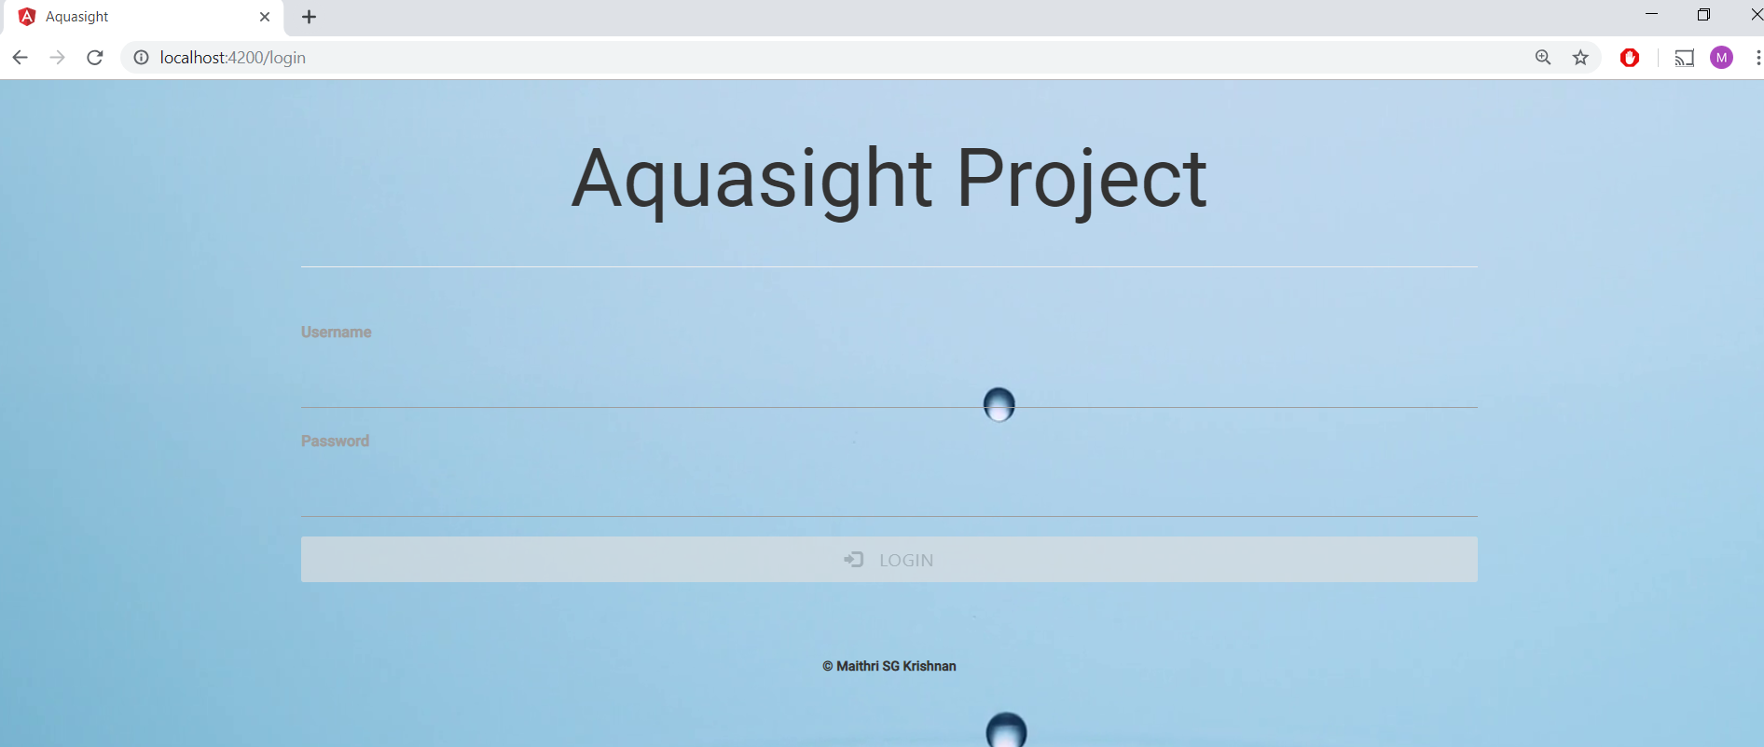

**Login Page – Validations:**

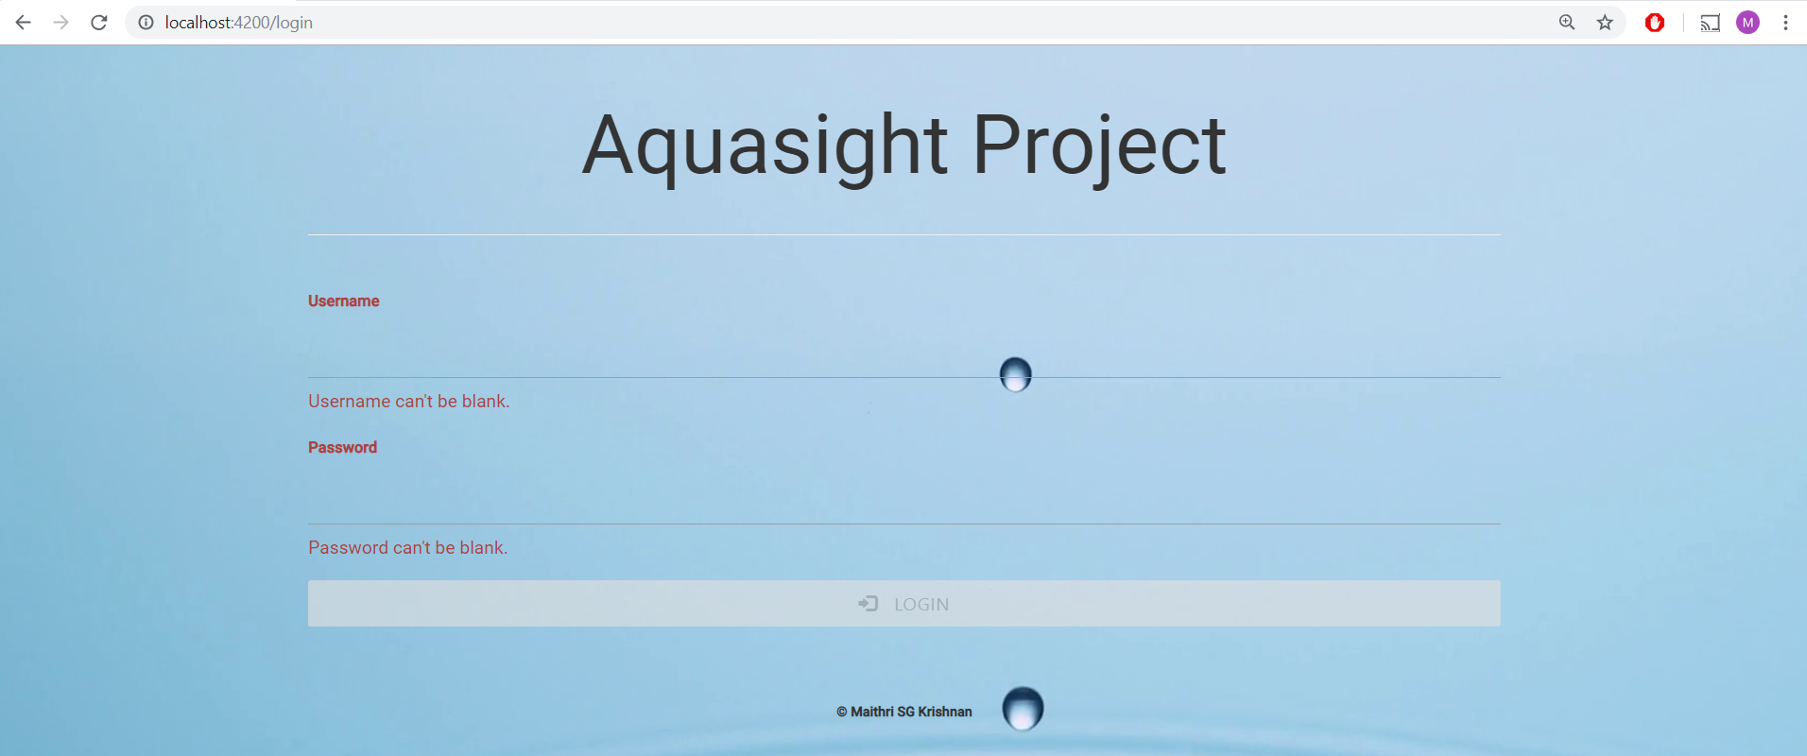

**The Login Button gets activated when the user enters the username and the password. Note the ripple effect on the Login Button.**

**On incorrect credentials:**

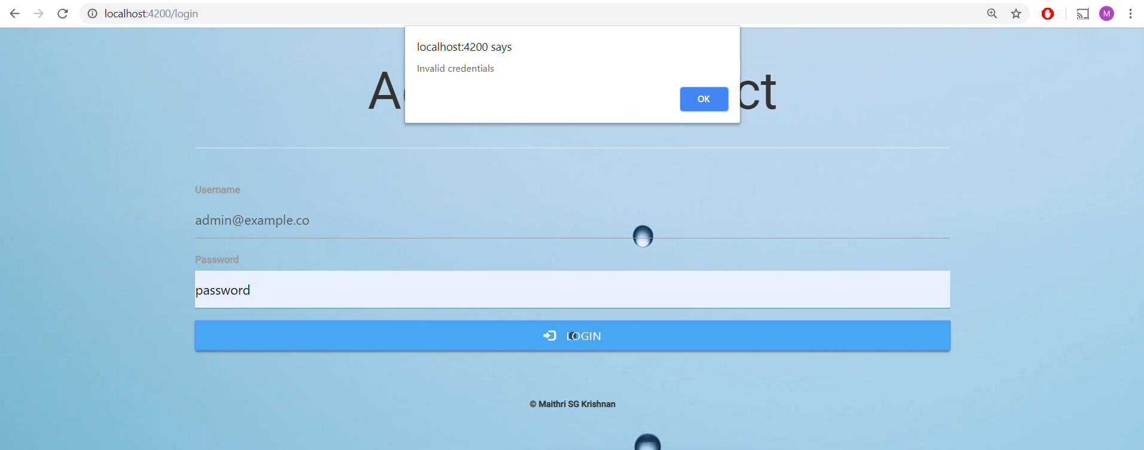

**On entering valid username and password, once the Login button is clicked, the browser is redirected to the forms page.**

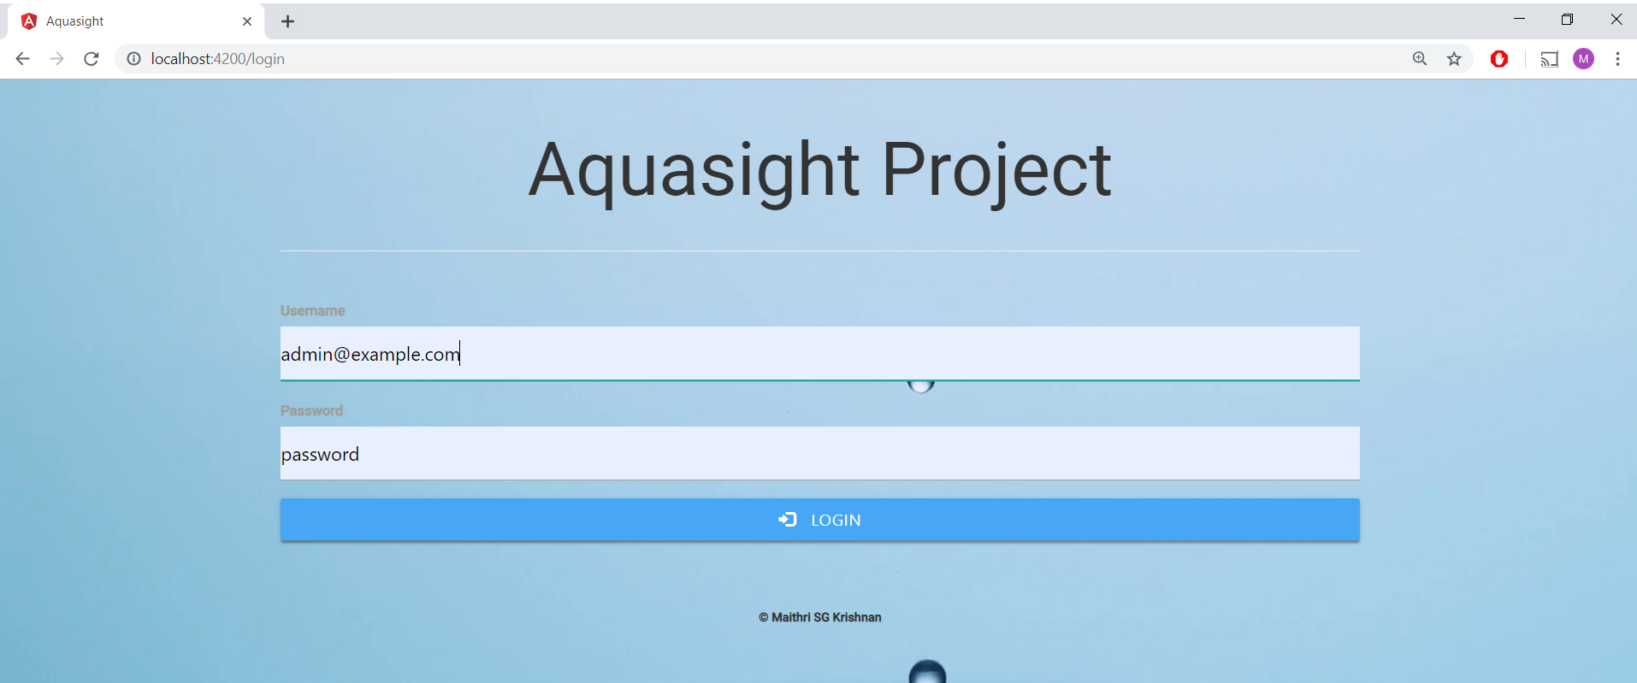

**The user is added to the local storage and the paths – localhost://4200/form and localhost://4200/chart are authenticated using Angular Guards.**

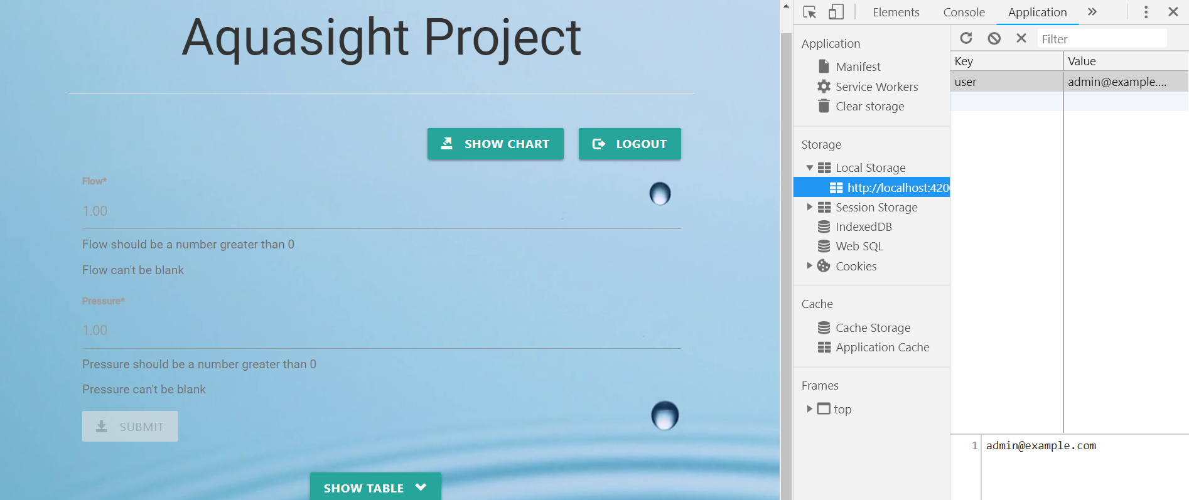

**The Form Page:**

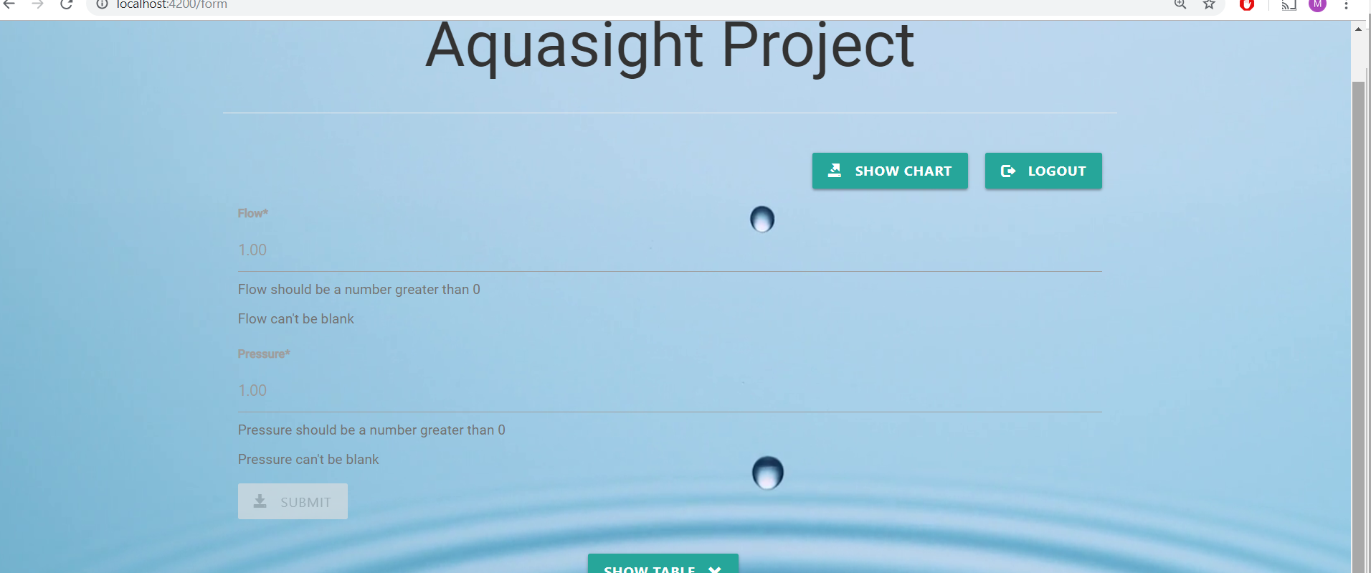

**The Submit Button of the form is disabled. Once the user enters both the flow and pressure values, the submit button becomes active.**

**The Show table button triggers collapsing and expanding the table (implemented using NgbModule – Angular powered Bootstrap => ng-bootstrap)**

**The data on the table is rendered from the database and is sorted by latest timestamp. All the columns of the table are sortable and pagination enabled (implemented using Angular Material)**

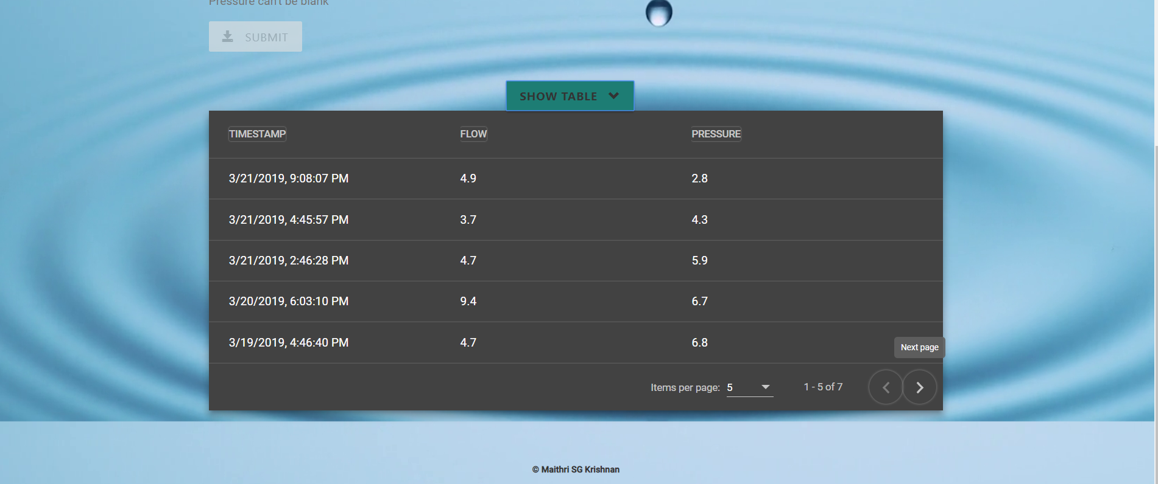

**The items per page can be adjusted to 5, 10, 25 or 50. The default is set to 5.**

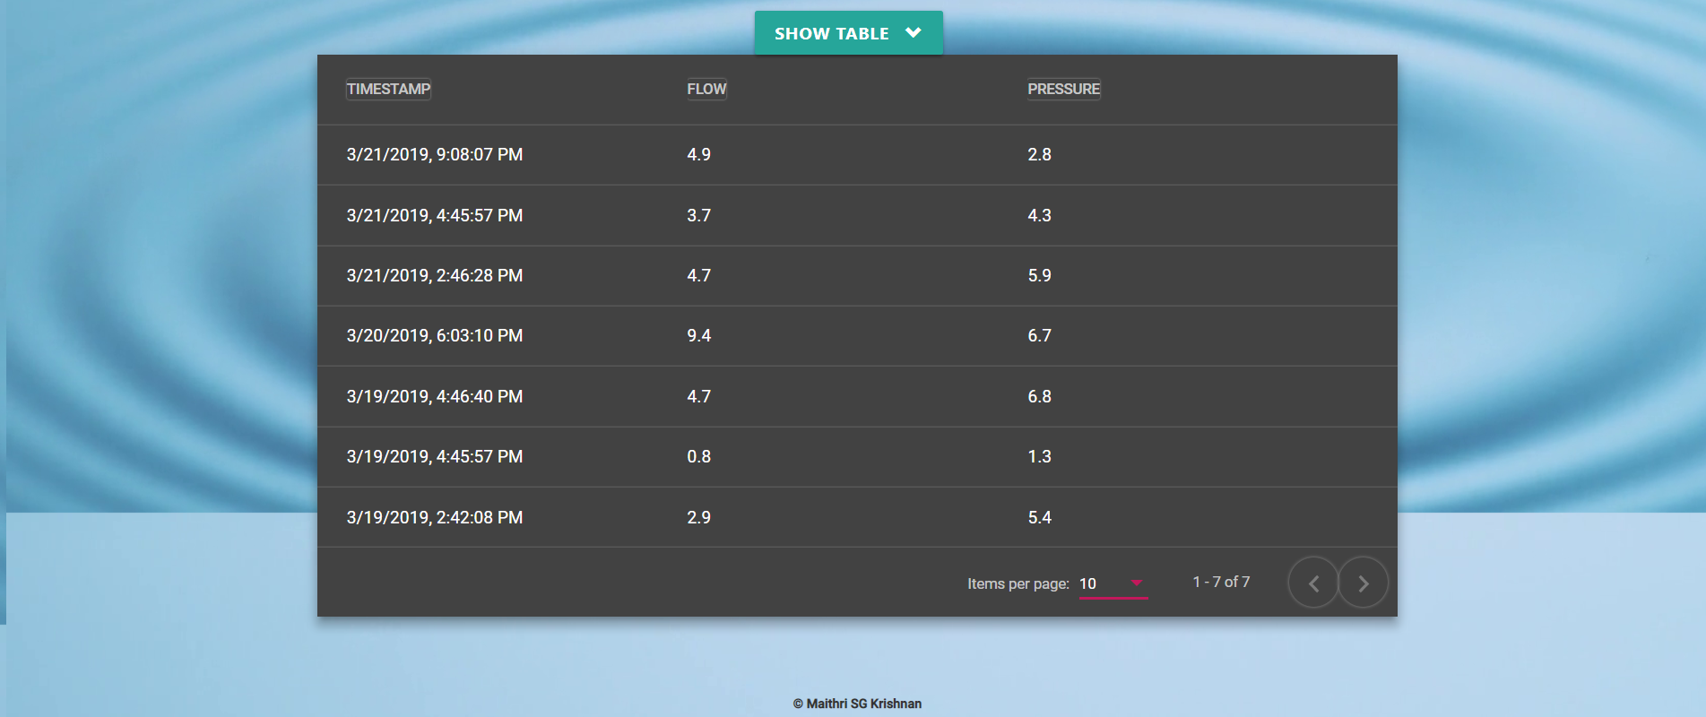

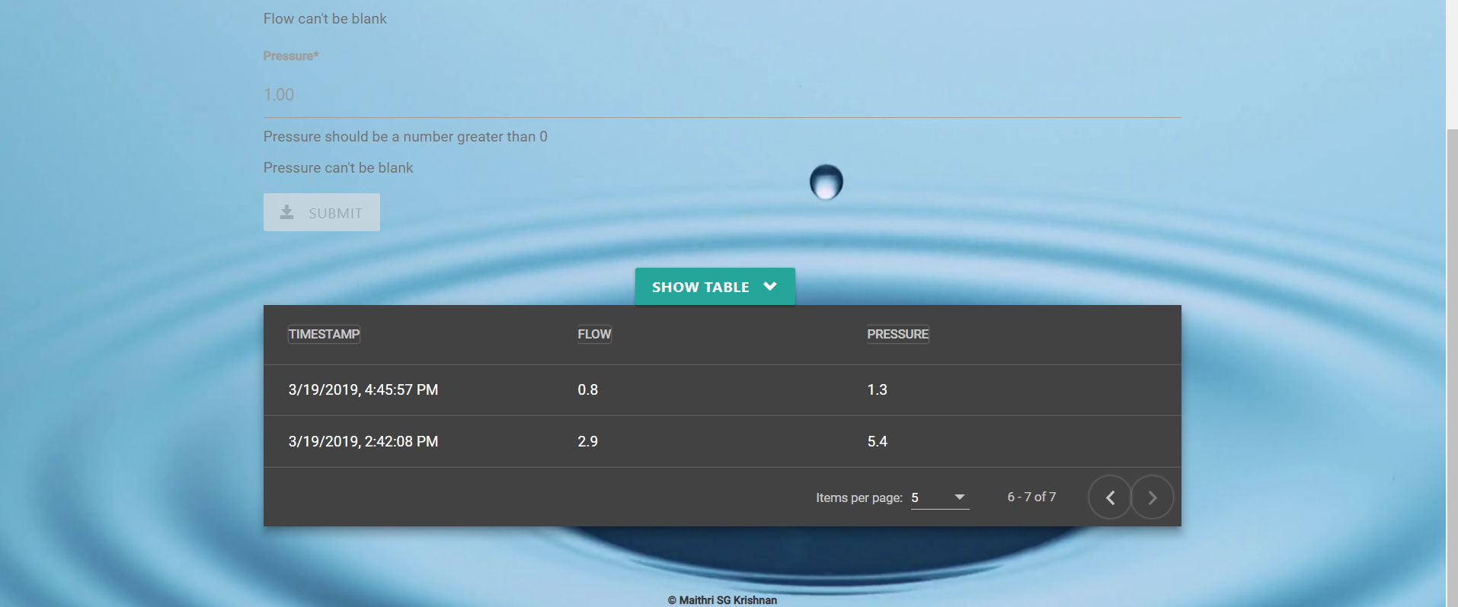

**The Logout button navigates to the login page of the application.**

**The Show Chart Button opens the chart as a popup dialog (implemented using Angular Material). The dialog comprises of two button – the close and the expand button.**

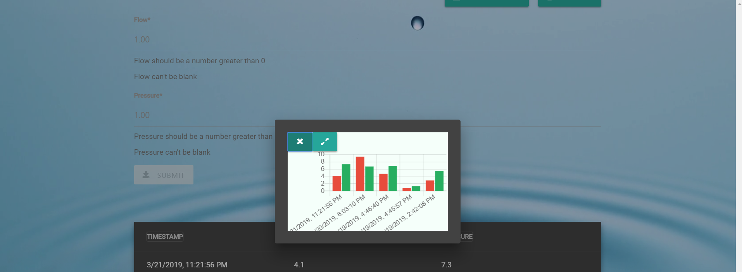

**On clicking the close button, the dialog displaying the chart, can be closed. The expand button navigates to the url –** [**localhost:4200/chart**](http://localhost:4200/chart) **and the user gets a bigger view of the chart.**

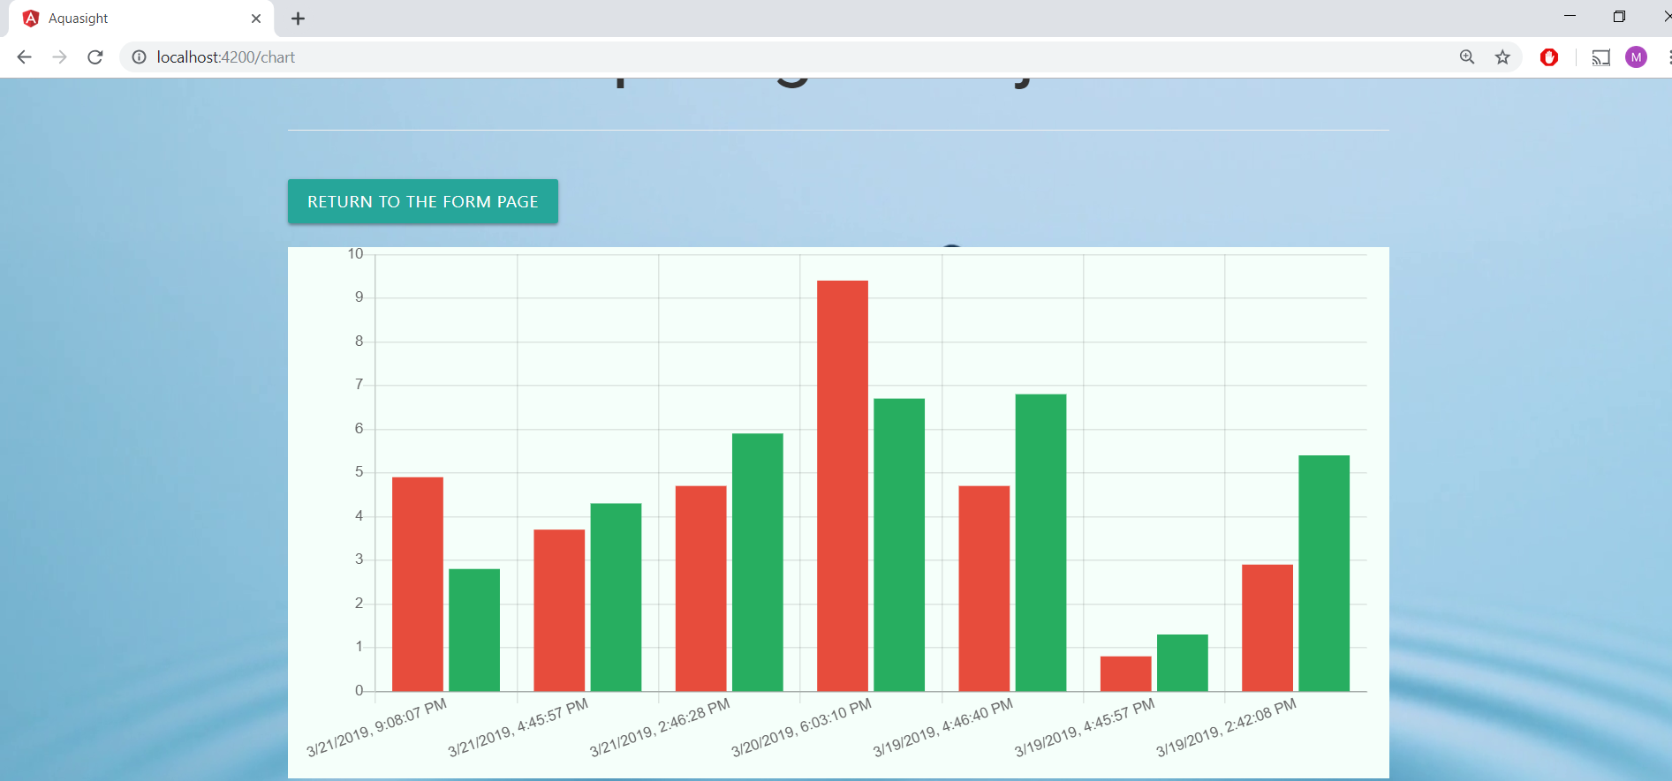

**The user can return to the form page by clicking the “Return to the Form Page” Button.**

**In the form page, once the user enters the flow and pressure values, the submit button becomes active.**

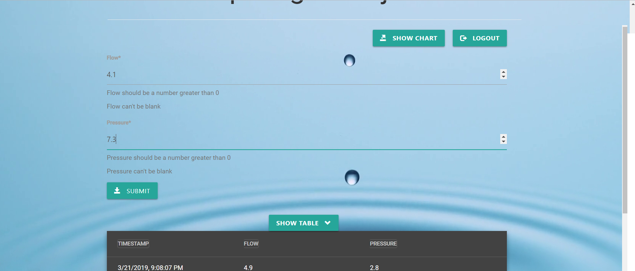

**By clicking the submit button, the values are added to the database and are displayed along with the timestamp on the table. The form fields are reset.**

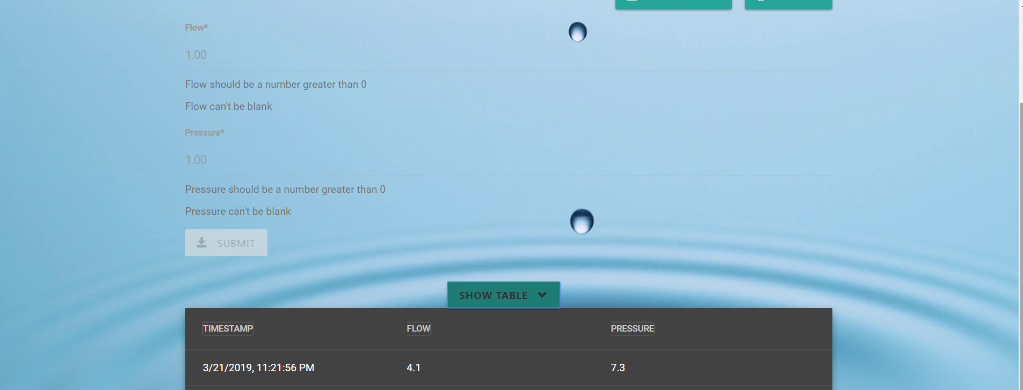

**When an invalid url is requested by the user, the 404 page is displayed**

